Hybrid Financial Ecosystems: A Quantitative Analysis of Satisfaction Determinants and Digital Adoption in the Romanian Banking Sector (2026)

Author: Grigore Mihai
Date: January 28, 2026
1. Abstract
Over the last decade, the Romanian banking sector has undergone an accelerated process of physical disintermediation, migrating from the traditional, branch-centered model towards ubiquitous digital ecosystems. This study explores the fundamental reconfiguration of the client-institution relationship in an era defined by the competitive pressure of Fintechs and the maturation of Open Banking solutions. The research is premised on the fact that digitalization no longer represents an optional competitive advantage but a condition of existence, although its impact on consumer loyalty remains variable and strongly dependent on the demographic profile. To test this premise, the study employed a quantitative approach based on a structured survey applied to a representative sample of 204 respondents selected from Romania's active urban population in October 2025. The analytical methodology included descriptive statistics to evaluate general trends and a Multiple Linear Regression analysis where the dependent variable was the importance of digitalization and the predictors were age, net income, and education level.
Data analysis reveals a high average preference for digitalization, indicating the transformation of mobile services into a hygiene factor. However, the regression model uncovered critical nuances, identifying a statistically significant negative correlation between age and the importance attributed to digitalization. The data suggests a clear dichotomy where the 18-35 age segment prioritizes transactional speed and user experience while mature segments remain attached to perceived security and human validation. Furthermore, income demonstrated a positive correlation, confirming that segments with high purchasing power associate digitalization with time efficiency. The study concludes that the optimal strategy for the 2026 horizon is not the complete abandonment of human interaction in favor of automation but the adoption of a hybrid model that offers flawless processes for day-to-day operations while retaining human touchpoints for critical advisory roles.
2. Introduction
Until recently, the banking relationship was synonymous with a physical ritual involving a trip to the branch, pulling a queue ticket, and waiting at the counter for a simple balance inquiry. Today, this ritual has almost completely disappeared from the daily life of the urban Romanian, as money has become invisible and circulates through digital impulses initiated from a sofa or the subway. This transformation is not merely technological but psychological, as the mobile phone has effectively become the most visited bank branch.
Applications such as Revolut, BT Pay, or George have redefined the standard of normality, leading the consumer of 2026 to compare their bank with the seamless experience offered by non-banking apps rather than traditional competitors. However, digitalization comes with the hidden cost of depersonalization, meaning that when the only interaction with the bank is a chatbot or a push notification, loyalty becomes volatile. The central question of this study addresses what matters more to Romanians today, weighing the speed of the application against the assurance of human support in case of fraud.

3. Context of the Romanian Banking Market

The Romanian market is currently a battleground between traditional giants and fintech players. Fintech companies have imposed a standard of instant gratification, offering the ability to open an account in minutes or split bills instantly, which has forced classic banks to adapt. In response, traditional banks have counterattacked by launching complex ecosystems or distinct digital-native brands, such as Salt Bank, which integrate payments, insurance, and loans, making mobile banking the preferred channel for the majority of urban adults. Concurrently, the number of active banks has dropped significantly due to mergers and acquisitions, meaning that only players capable of sustaining massive investments in IT and cybersecurity remain competitive

4. Methodology

To understand the voice of the customer, a quantitative research study was conducted in October 2025 using a sample of 204 respondents randomly selected from the urban environment. The profile of these respondents covers the entire spectrum from Gen Z to Baby Boomers, with incomes ranging from minimum wage to over 10,000 RON per month, and occupations spanning IT, Finance, Legal, and Education sectors.

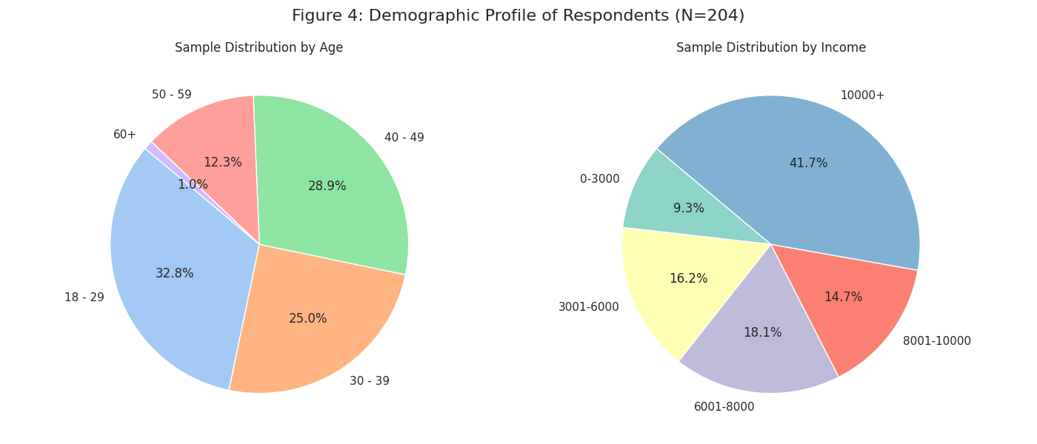
Since the questionnaire included ordinal scale responses, a preliminary step of numerical transformation was necessary to convert qualitative responses into a 5-point Likert scale, allowing them to be treated as interval variables.
The mathematical model defined for this study uses a linear equation where the dependent variable represents the importance score attributed to banking digitalization. The model calculates an intercept representing baseline satisfaction and regression coefficients that indicate the magnitude and direction of change for each demographic predictor, allowing the analysis to isolate specific effects such as the decrease in digital dependency associated with increasing age.

5. Results and Data Analysis

The analysis of responses shows an extremely high level of exigency, with the average importance of digitalization reaching a score that classifies it as essential.
A bank without a high-performance app is practically invisible to the analyzed sample, yet security remains the top priority, often scoring slightly higher than digitalization due to fears regarding phishing and online fraud.

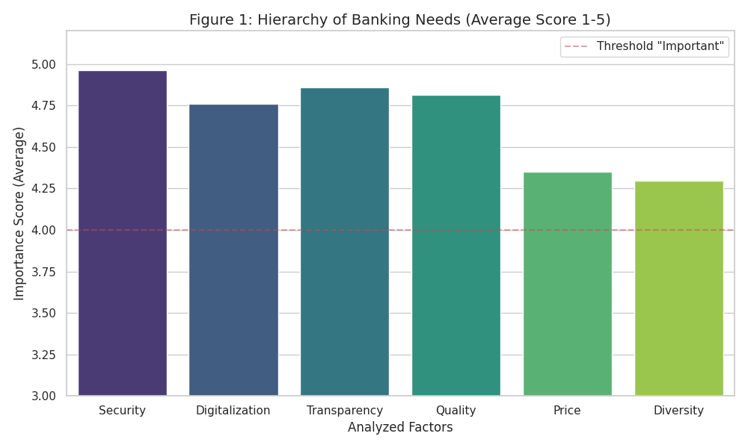
The mathematical regression model revealed several clear trends, most notably an inverse correlation between age and digital dependency. Young people are the most critical of technical friction, while tolerance for classic processes increases with age.
Additionally, clients with high incomes place greater pressure on digital efficiency because they view time as a financial resource and demand instant execution without paperwork. Surprisingly, the level of education does not significantly influence preference, suggesting that banking apps have become so intuitive that the educational barrier has effectively disappeared.]

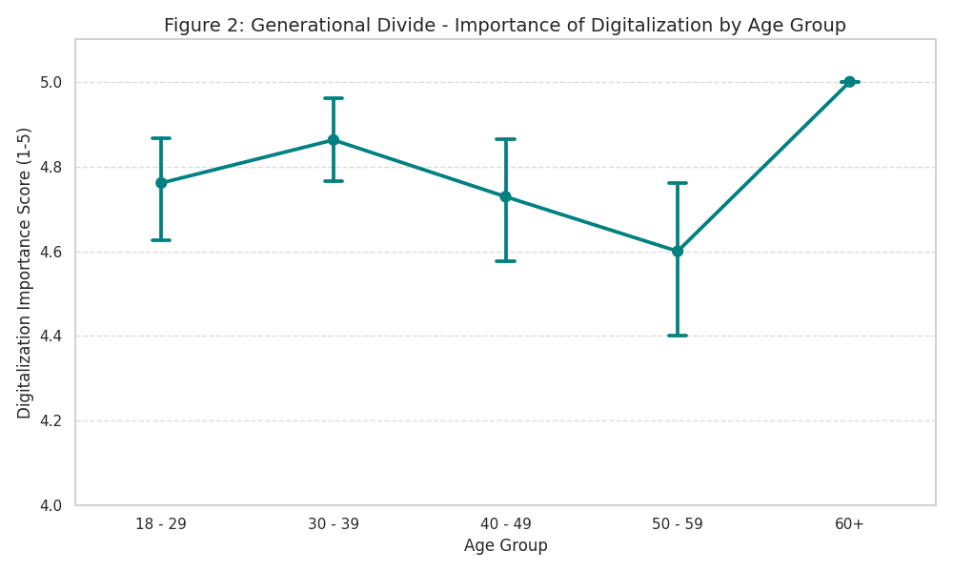

6. Discussion

Data analysis reveals a complex picture of current financial behavior dominated by a veritable paradox of comfort. Although a nostalgia for traditional human interaction persists at a declarative level, consumer actions invariably validate institutions that allow for full remote financial management. However, this digital efficiency shows its limits in critical moments, such as security incidents or technical blockages, when the automated barriers of virtual assistants transform from facilitators into major sources of frustration. Simultaneously, a strategic mutation of banking apps is observed as they transcend strict transactional functionality to become complex lifestyle platforms. By integrating ecosystems of adjacent services ranging from road tolls to personalized commercial offers, banks are adopting a super-app model to remain relevant. Nevertheless, the generalized enthusiasm for digitalization hides the risk of a deep social divide, as the aggressive elimination of physical interaction points can generate financial exclusion for senior demographic segments.

7. Conclusions

The study demonstrates that the digital transformation of the Romanian banking sector has surpassed the option phase and entered a stage of critical necessity where user experience becomes imperative. For the young and economically active segment, the app interface is more important than the branch location, and a slow app is immediately penalized by migration to the competition. However, the ideal model identified is not a fully robotic one but a hybrid one, where success belongs to banks that offer impeccable technology for routine transactions but maintain accessible human interaction for complex situations. Looking forward, the future becomes predictive, evolving from simple payment execution to automated financial counseling based on hyper-personalization, through which the bank anticipates the client's savings needs before they even become evident.

8. References
- CECCAR Business Magazine. (2025, May 15). Studiu: Aproape două treimi dintre adulții din mediul urban folosesc servicii de Mobile Banking. CECCAR Business Review.
- MobiFin. (2024, December 10). Top 10 Fintech Trends in 2025: Reshaping the Future of Finance - Hyper-personalization and AI. MobiFin Blog & Industry Reports.
- Piața Financiară. (2026, January 26). Cum a fost 2025 pentru românii care au investit prin Revolut: Statistici și comportament tranzacțional.
- Ziarul Financiar. (2026, January 08). Anul 2025, cel mai puternic an pentru consolidarea bancară: Numărul băncilor active a scăzut sub 30 în urma fuziunilor. ZF Corporate.
- Grigore, M. (2026). Hybrid Financial Ecosystems Survey: Percepția consumatorilor români asupra digitalizării bancare [Unpublished raw data]. Dataset propriu, N=204 respondenți.
- Juniper Research. (2025). Top 10 Fintech & Payments Trends 2025. White Paper on Global Financial Markets.

